DeVeau’s Dragons All-Star Cheerleading
Tryout Packet 2017-2018

I. Welcome to the Team!

DeVeau’s All-Star Cheerleading program would like to welcome your family to our program. This handbook will outline important policies, procedure, and expectations of your family and your athlete. Be sure to keep it somewhere you can reference if needed.

There is no doubt that joining one of our competitive teams is a significant commitment of time, energy, and money. Is it worth it? Most parents will say that other than family life, team involvement becomes the most significant event in their child’s life. Besides the obvious physical benefits, children who become involved in team sports rarely accept negative influences into their life. They learn self-discipline, how to work closely as a member of a team, how to handle themselves in a large variety of situations, and how to prioritize and manage their time. Parents of our team members often comment that they wish they possessed their athlete’s discipline and time management skills! Our team kids are almost always excellent students. For these reasons and more, team membership is a wonderful, challenging journey.

II. Introduction to DeVeau’s

DeVeau’s Dragons All-Star Cheerleading program is here to provide your family with the best instruction, facility, and family atmosphere all under one roof! Our cheerleading program benefits from its proximity to some of the best tumbling instructors in the country— many even coached an Olympic gymnast. In addition to our growing facility, our program is led by Reece White and Taryn DeVeau Lautzenheiser. Reece White is a UCA Collegiate National Champion Cheerleading Coach and former member of the 22-time National Championship Cheerleading Team at the University of Kentucky. Taryn is also a former member of the 22-time National Championship Cheerleading Team at the University of Kentucky, competed All-Star cheerleading and gymnastics at DeVeau’s, and has coached children of all ages in both gymnastics and cheerleading at the gym.

DeVeau’s current location in Fishers, IN boasts over 56,000 square feet and houses over 45 instructors. The New Cheerleading Wing will house two new cheerleading floors, a tumble track, a rod floor, four trampolines, and foam pits to enhance skill development. The expansion open in May 2017. Over the past 30 years, DeVeau’s has grown to over 300 competitive gymnasts and cheerleaders on team and over 1,200 students in recreation classes. Despite our record number of students, and the largest recreation and team programs in the state, DeVeau’s has maintained its values of a fun, family atmosphere that loves to see children enjoy learning and understand the value of earning success.

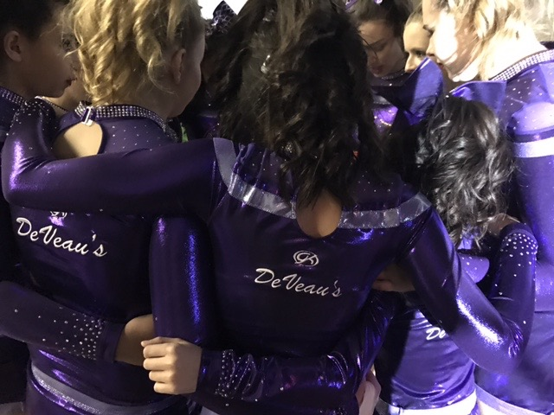
In addition to the students currently enrolled, DeVeau’s has had thousands of students through our doors over the years, and many contribute their triumphs to the foundation and life lessons they received at DeVeau’s. While we began as a gymnastics school, it is in collegiate cheerleading that DeVeau’s students have seen even more success. Former DeVeau’s gymnasts and cheerleaders have gone on to cheer at the University of Kentucky (22 time national champions), Indiana University (4 time national champions), University of Alabama (National Champions), Purdue University, Indiana State University, Butler University, and many more. Over 40 gymnasts have received college scholarships and continued to compete gymnastics in college at schools such as Brown University, University of Alabama, UCLA, University of Illinois, University of Pennsylvania, and many more.

DeVeau’s Dragons is the place for your child to learn the values of hard work, persistence, and teamwork, and where she/ he will form lifelong friendships. If you’re looking for an upbeat, family atmosphere, DeVeau’s is the place for you.

III. Handbook Roadmap

Please turn in the DeVeau’s School of Gymnastics Release of Liability and Waiver, Team Member Registration Form, and Parents Authorization for Another to Consent to Medical and Dental Treatment before tryout clinics. The Financial Commitment Form, Code of Conduct Form, and copy of birth certificate may be turned in at the Parents Meeting.

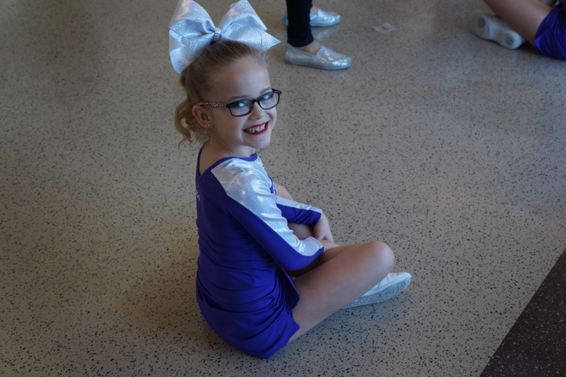
Parents Meeting: Thursday, May 11th at 6:30 pm for ages 5-11 years and 7:30 pm for ages 12 years and older. In addition to these forms, a non-refundable $45 Tryout Fee is due prior to the start of clinics.

Tryouts: Thursday, May 11th^{nd} from 6:00 – 7:30 pm for ages 5-11 years old and from 7:30-9:00 pm for ages 12 years & older.

Tryout Clinics: Tuesday, May 9th from 6:00-7:30 pm for ages 5-11 years old and from 7:30-9:00 pm for ages 12 years & older.

Practices be begin the Week of Monday, May 15th.

IV. Team Placements

The cheerleading skills that are learned may only last for a small part of their life, the life skills that are learned will last forever. For this reason, we are dedicated to helping our cheerleaders learn self-motivation, determination, perseverance, the power of teamwork, compassion, and a self-worth based on effort and character rather than performance and outcome. Each child develops at a different rate. Our team coaches will place cheerleaders at the level where they can be happy, safe, and confident.

Our coaches will try to place athletes by level to the best of our ability, but there may be athletes on any team with different tumbling abilities than their teammates. Some athletes may excel at stunting or jumps and others at dance or motions. Every cheerleader is placed on the team for a reason and the athletes are chosen for a team to make the group succeed as a whole. Please trust our coaches—they are looking out for the best interest of the team as well as the individual athletes.

The age guideline below is provided to help you understand which team your cheerleader may be eligible for the 2017-2018 season. Age is determined as of August 31, 2017. The level refers to the type of tumbling, stunts, and pyramids that a team is able to perform consistently and safely in a competition. They are numbered in increasing difficulty from numbers 1 to 5.

Tiny | 5-6 years old
Mini | 5-8 years old
Youth | 6-11 years old
Junior | 8-14 years old
Senior Level 1 - 4 | 11 years - 18 years old
Senior Level 5 | 12 years – 18 years old

V. Tuition and Financial Policies

Gym Fee Schedule

Annual Registration Fee (per family) $50

Practice Gym Fees

Local Prep Squad Practice 2.5 hours per week: $120 / month

Travel Squad Practice 4 hours per week: $165 / month

Travel Squad Practice 5 1/2 hours per week: $185 / month

Travel Squad Practice 7 hours per week: $195 / month

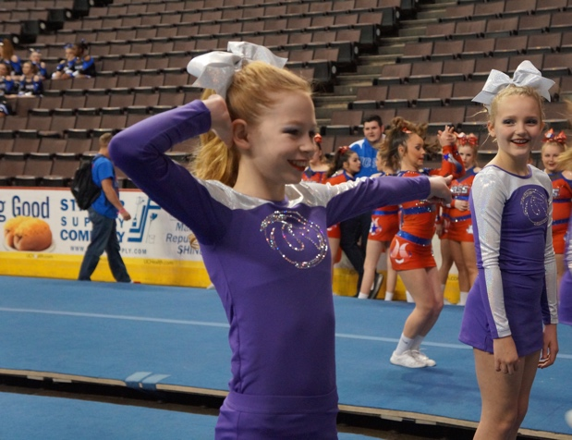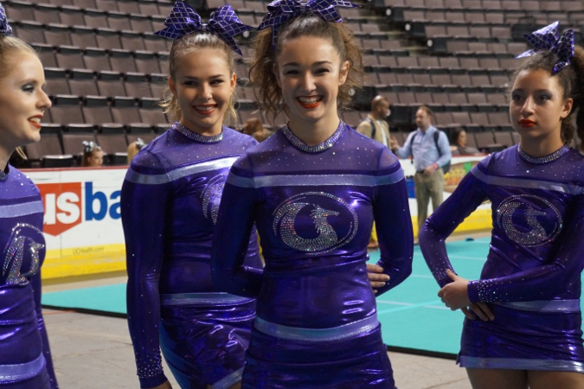

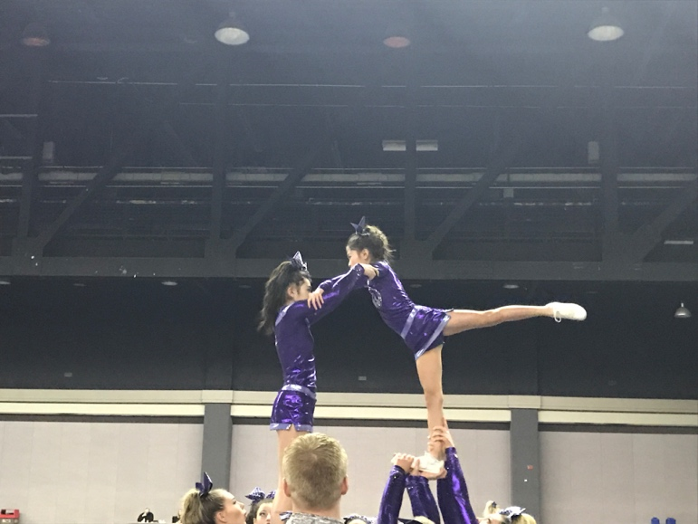

Tuition in the team program is based on approximately 48 weeks of training per year. Monthly tuition payments are determined by considering the cost of the total program for the year - not a per-hour charge. The total program cost is divided into 12 equal monthly payments regardless of the number of training hours that month. Tuition payments are due on the first of each month for 12 months, regardless of attendance. Team members do not move onto and off the team based on illness, injury, conflicts, or the like. You are either on the team or not. Keep in mind; team tuition would be higher if we based tuition on the likelihood that some of the members might be paying a reduced tuition for one reason or another. The gym will be closed for two weeks during the year. A cheerleader will not be allowed to compete if his/her team fees are not current for the month. Unpaid balances over 60 days overdue may terminate your child’s participation at DeVeau’s School of Gymnastics.
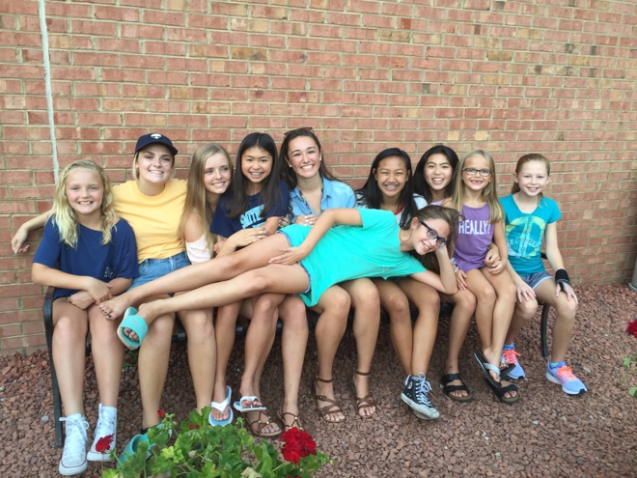

Autopay Required

All team members are required to have a credit card/debit card on file. All team accounts will be charged by autopay on the 1st of the month. This will help to ensure payments are made on time. If you wish to make payment by another form (check, cash, or in person), please do so prior to the 1st of the month. Any accounts with a balance will be charged on the 1st of each month. If the card on file declined and payment is not made by the 8th of the month, a $25.00 late fee will be assessed.

Refund Policy

DeVeau’s does not offer refunds for any reason (injury included) nor do we pro-rate for missed training sessions. Monthly tuition is determined by considering the cost of THE TOTAL PROGRAM and not a per hour charge.

Cancellation Policy

Cheerleading is a team sport and all members of the team are needed throughout the season. If an athlete decides to discontinue the program and not complete the All Star Season they are STILL responsible for ALL gym and booster club fees for the remainder of the season. This contract is enforceable to the fullest extent possible under Indiana law.

Estimated Booster Club Fees

Please note that all fee and practice schedules are tentative and subject to change. These Booster Club Fees provide an example of fees from the 2016- 2017 season. These fees will vary depending upon the number of competitions and the level of the squad. Full-year teams will have between 6 and 8 competitions. Practice wear is not included and will be ordered at the first practice. It will include t-shirt and tank-top options with your choice of shorts or leggings.
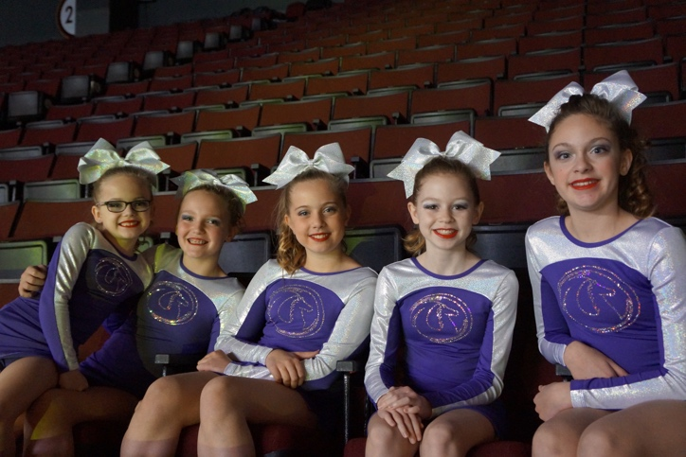
Approximate Booster Fee total is $817 - $1,903 for the year. This fee is approximated until we have the competition schedule and competition fee total set for the year. The competition fee from last year is included. The total fee will be made in 9 monthly installments of $91 - $211 beginning in June and ending with the February payment. The fee varies based on the age and ability level of the squad with Prep team’s fees being around $90 per month and Juniors/ Seniors being around $209 per month. Tiny team’s fees will be less. The 2017-2018 All Star Travel Squad includes the following fees:

- Administrative Fee – $30.00 per family. This fee is needed to help the Booster Club in covering the fees associated with accepting credit card payments.

- Warm-Up Suit Cost - $100.00. Suit includes jacket and pants with DeVeau’s Dragons cheer logo.
- Approximate Uniform Costs – $130-375. Lower level uniform is $130. Upper level uniform is $375.
- Competition Bow - $25
- Booster Club Fees - $128 – Covers the cost of spirit gifts, coaches’ gifts, miscellaneous operating expenses of the booster club and year-end banquet expenses.
- USASF Membership Fee - $30.00 - The US All Star Federation (USASF) was founded in 2003 with the core principle of making all-star a safer sport by establishing fair and consistent rules and competition standards. The organization credentials coaches, certifies safety judges, sanctions events and maintains and adjusts (as needed) safety guidelines, all with the goal of providing the safest possible environment for cheer and dance athletes to train and compete.
- Approximate Competition Fees - $253 - $927 – Covers the cost of the entry fee to the various competitions and coach’s stipends. These costs do not include your personal travel expenses. These fees DO NOT cover year-end bid competition entry fees. NOTE: THESE ARE LAST YEAR’S COMPETITION FEES.
- Choreography/Stunt Clinics/Music Fees - $121-$304.

Cheer Shorts/Shoes/Socks
Please note that cheer shorts, shoes and socks (for both practice and competitions) will be purchased by each family and are not included in the costs above. Shorts are to be black running shorts. We will provide you with locations where you can order your cheerleader’s shoes. Socks for competition are white no-show. Please watch for additional information, which will be provided towards the beginning of the season.

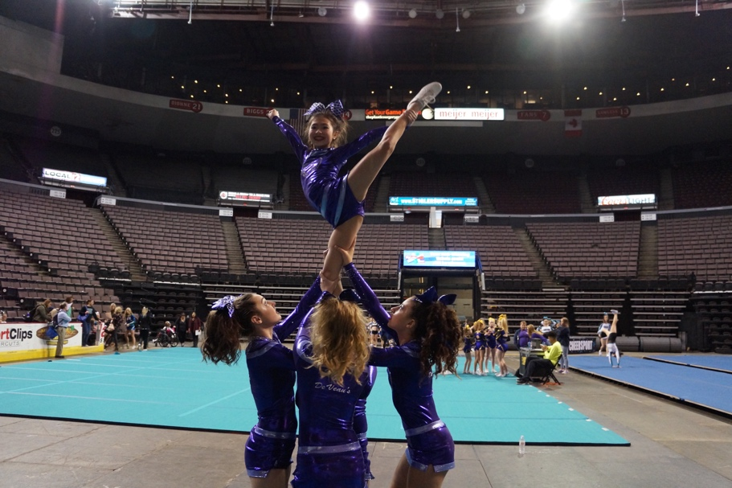

PAYMENTS OF BOOSTER FEES
Booster club fees must be paid on time and all checks or money orders should be written to Cheers All-Star Booster Club. Late payments of fees could result in the cheerleader having to sit out of practice until all fees are current. A cheerleader with a delinquent account may not be registered for competitions and if not brought current within 14 days, the cheerleader’s spot on the squad could be forfeited.

Check or Money Order Payments
Payable to Cheers All-Star Booster Club and should be placed in the Booster Club’s payment box located at the back of the DeVeau’s break room.

Credit Card Payments
- We accept the following credit cards for booster payments: Visa, MasterCard and Discover.

- We do not accept American Express or debit cards (we accept combo credit/debit cards as long as they can be processed as a credit card).
- We will NOT accept credit card payments for fundraising or anything other than the aforementioned fees.
- We also require each family to keep a credit card on file with us. The credit card authorization form must be completed and turned into our Booster Club Treasurer no later than 5/12/16. You will have the option to have the Booster Club automatically charge all 8 monthly Booster fees to this card. Also if you are more than 7 days late making a Booster Club payment, we will automatically charge the credit card on file with us.
- All credit card information will be kept completely confidential. Any fees associated with a declined credit card will be added to your booster balance ($20).

Returned Checks

All returned checks must be paid by money order along with a $25 service charge.

VI. Practice Schedule

Practices will begin in May. Days and times are TBD. Younger age groups will practice earlier in the evening and older age groups will practice around 6:00-8:30 pm.

Local Prep Squads will practice once per week for 2.5 hours

Travel Squads practicing 4 hours per week will practice twice per week for two hours. Tumbling will be built into the practices

Travel Squads practicing 5 ½ hours per week will practice twice per week for two hours plus have an additional hour and a half for tumbling.

Travel Squads practicing 7 hours per week will practice three days per week for two and a half hours.

VIII. Crossover Rate

Beginning this year, cheerleaders will have the option to cross-over between multiple squads and compete on multiple squads if selected. The cross-over gym fees will be 100% of the gym fees for the first squad and 50% of the gym fees for the second squad. Cheerleaders are expected to attend all practices for both squads. Cheerleaders cross-over competition fees are charged at 100% for the first competition fee and 50-75% for the second competition fee paid.

IX. Booster Club General Information

DeVeau’s Cheer Booster Club, Inc. Mission

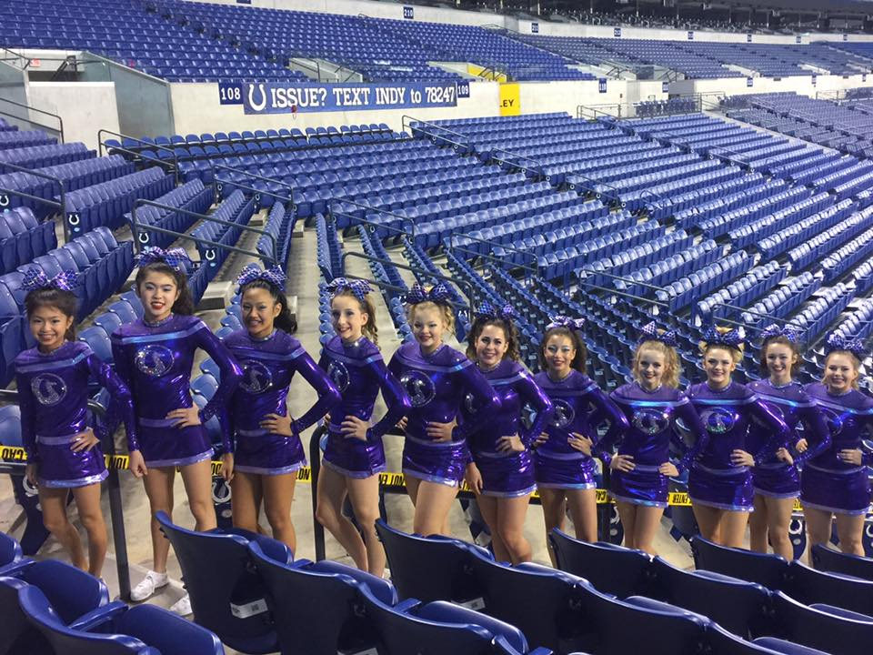
DeVeau’s Cheer Booster Club is a not-for-profit organization exempt from federal income tax under section 501(c) (3) of the Internal Revenue Code and established to provide support for the cheerleaders and coaches of DeVeau’s.

Financial support is given to assist in the cost of competitive cheerleading including competition fees, uniform expenses, and coaching expenses for the DeVeau’s Dragons Cheerleaders.

Educational support is given through providing coaches with the opportunity to attend professional coaching clinics and by providing skill and technique development for the DeVeau’s Dragons cheerleaders.

Team support is provided through activities that generate team spirit and recognition for the DeVeau’s Dragons Cheerleaders.

Meetings and Communication

The Booster Club will meet the first Thursday of each month at 7:00 PM. Additional meetings may be added as needed for various events such as fundraising, event planning, etc. Any participating in these additional meetings will be notified of the date/time as soon as possible.

Booster Club Board meetings will be held monthly. In addition, the DeVeau’s Dragons staff asks that each all-star family provide their e-mail address. Please use an e-mail address which will be checked at least every 2 days for team updates, reminders, meeting minutes, competition info, fundraising info, etc.

You will receive information via:

- E-mail
- Team Snap
- Mailboxes at the Gym
- Booster/Parent Meetings

COMPETITIONS

Schedule
A schedule of competitions for the season will be provided as soon as it is confirmed by the cheer program director.
Prep level 1 - Approximately 3-4 local
Mini & Youth - Approximately 3-4 local +1-2 Regional
Junior & Senior – Approximately 3-5 local + 2-3 Regional + 1 possible extended travel trip

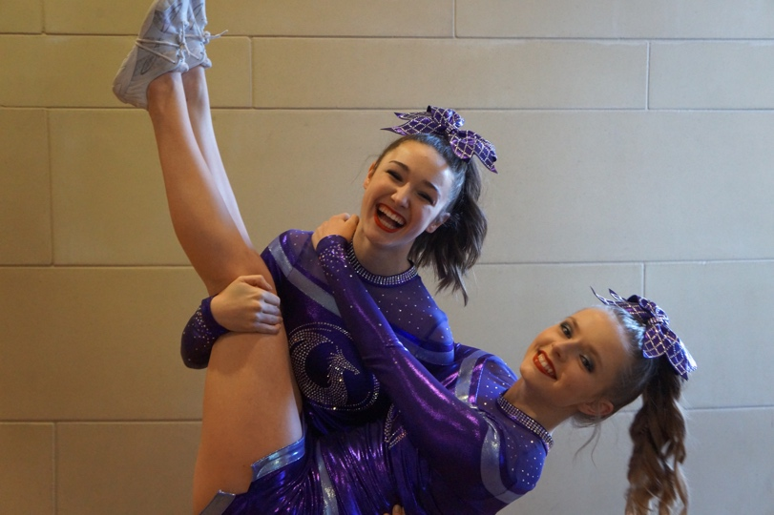
Travel/Accommodations
All transportation and accommodations for cheerleaders and their families to the competitions will be the sole responsibility of each family. It is recommended that you plan to stay overnight for any out-of-town competitions/events and reserve a hotel room. Please ask what the hotel’s cancellation policy is as you may decide to drive the day of the competition once the competition schedule is available (usually 5 to 7 days before the competition). Any money that parents spend regarding travel for themselves, family members and friends to competitions and other events is done at their own risk. DeVeau’s Dragons will do our best to get information to you in a timely fashion; however, if for any reason a competition is cancelled or rescheduled, DeVeau’s Dragons will not be responsible for any reimbursement of your travel arrangements.

Who will be competing?
Every member of the team is NOT guaranteed to compete at every competition. The head coach of the team will have final say of who will be competing at a particular competition. Reasons why an athlete may not be able to compete at a particular completion may include but are not limited to; injury, illness missing practices, unable to perform level appropriate skills, poor attitude, poor work ethic, suspension.

ACTIVITIES/EVENTS

Activities for the cheerleaders and/or families will be planned throughout the season. There are plenty of opportunities to get involved!!! Examples include: team/program parties, fundraising (chairing one fundraiser and/or helping with delivery and pick-up times), end-of-year banquet, etc.

Please note, that by “family” we mean parents, step-parents, grandparents, siblings, etc.
Participation is a great way to meet other DeVeau’s Cheer parents!

FUNDRAISING ACTIVITIES
Fundraising activities are held throughout the year. The purpose of fundraisers is to generate funds to support our program and your cheerleader(s). Past fundraising opportunities include: sponsorship for the team shirt, Abby’s Candles sales, pizza sales, Scrip Program (gift cards), and spirit wear sales.
Additional fundraising information will be provided before each fundraiser via email, handouts in your child’s mailbox, the bulletin board, etc. Please check each of these frequently to ensure you do not miss out on these fundraising opportunities.

X. Cheerleading Code of Conduct

Attendance Policy

Cheerleading is a team sport and all members are affected when one person is missing. Cheerleaders must be on time and wear proper practice uniforms to all practice sessions. All Cheerleaders are required to wear sports bras to practice, regardless of age.
Attendance at all practices and competitions is mandatory unless written notice has been given to the coach prior to practice – this notice can be emailed.

Cheerleaders are permitted to miss 6 practices over the Summer (May-August) and miss 8 (12.5%) practices throughout the school year (September - April). Please plan your absences accordingly. Cheerleaders are NOT permitted to miss practice the week of a competition. Cheerleaders who are limited from practice due to injuries (doctor’s note must be on file) are still required to attend all practices and competitions.

Unexcused absences from either a practice or a competition will result in potential suspension from the team. An unexcused absence is an absence in which the coach has not been notified, the accumulation of tardiness, the absence of summer practices, inappropriate attitude, inappropriate work ethic, missing choreography camp, etc. Suspension will occur at the coach’s discretion and is not open for discussion.

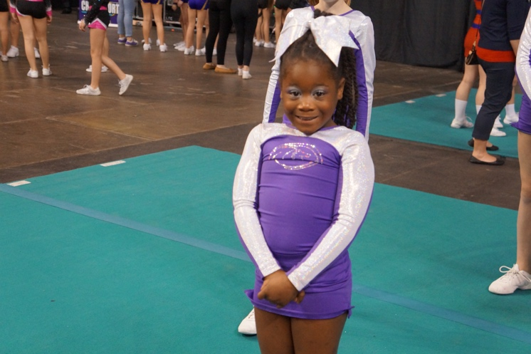

TARDINESS will be closely monitored during the season. If the athlete is not dressed and ready to practice when the coach calls practice to order, a significant disruption to practice can occur. Significant and continued tardiness may also lead to suspension at the coach’s discretion.

TRANSPORTATION - Cheerleaders must provide transportation to and from practices and competitions. A lack of transportation is not a valid excuse for missing practices or competitions. All personal grooming (including make-up, hair, etc.) must be completed before the competition arrival time. Travel expenses are the responsibility of each family.

Uniform - Cheerleaders will purchase their uniforms, shoes, socks, hair bows, warm-ups, practice clothes, etc. Cheerleaders may wear only the “appropriate uniform” as approved by the coach to practice and on competition days. A uniform being worn to competitions DOES NOT include sandals, sweat pants, sweat pants under cheer skirts, random T-shirts over cheer tops, hair down, large dangling earrings etc. Cheerleaders must keep all apparel clean and neat and maintain a well-groomed appearance at all times in and out of uniform. NO JEWELRY will be worn at practices and competitions. ONLY hair bows approved by the coach may be worn. NO NAIL POLISH will be worn at competitions. Visible BODY PIERCING will not be permitted while representing DeVeau’s Dragons All Stars. Coaches will closely monitor adherence to this rule.

All Cheerleaders are required to wear sports bras to practice, regardless of age.

Hair must be kept clear of the face at all times while in uniform. Hair will be pulled back in a ponytail with the appropriate hair bows. No other hair accessories are permitted. For practice, the attire must consist of the required practice shorts, t-shirt, cheerleading shoes and hair tie or hair bow.

Cheerleaders should always give and encourage support of all DeVeau’s teammates and squad(s).

Cheerleaders should continually strive to maintain harmonious relationships between all cheerleaders. There is not distinction of privileges between participants.

Cheerleaders should always be enthusiastic, a good sport, and an example of good citizenship.

NO CELL PHONES WILL BE USED DURING PRACTICES OR AT COMPETITIONS AFTER THE DESIGNATED ARRIVAL TIME.

Bad language will not be tolerated.

Individual movement of an athlete from team to team will be at the coaching staff discretion.

Statement of Financial Commitment

I understand and agree to the following:

- I have read and fully understand my financial commitment to DeVeau’s School of Gymnastics, Inc., which is outlined in the tryout packet.

- I understand that I will be charged by autopay on the 1st of the month and agree to provide an alternative form of payment than the credit card on file prior to the first of the month if desired.

- I understand that I am subject to a $25.00 late fee if the card on file declined and payment is not made by the 8th of the month.

- I understand that I will be responsible to pay for the full 2017-2018 season regardless of whether I choose to leave the program or if I am asked to leave the program due to any disruptive behavior.

- I understand that I am entering into this program on my own free will and that any unpaid monies will be turned over to a Collection Agency and may negatively affect my credit score.

Parent’s Signature: Date:

________________________________________________________________________

DeVeau’s Dragons All Stars Code of Conduct Signature Page

By signing, we agree to adhere to the rules set forth in the Code of Conduct document.

Cheerleader’s Signature: Date:

______________________________________________________________________

Parent’s Signature: Date:

______________________________________________________________________

DeVeau’s School of Gymnastics Release of Liability and Waiver
(Completed form must be presented to allow participation).
At DeVeau’s School of Gymnastics, safety is our main objective, but any activity involving height or motion increases the chance of injury.
I _______________________________, on behalf of my Child ________________________________, agree to RELEASE AND HOLD HARMLESS DeVeau’s School of Gymnastics, along with the officers, employees, instructors, volunteers, successors, or assigns (hereinafter, “Representatives”) against any and all claims for injuries, damages, and losses of any nature, whether known or unknown, including acts of negligence of DeVeau’s School of Gymnastics and its Representatives, sustained by my Child which are in anyway related to his or her participation at DeVeau’s School of Gymnastics in Fishers, IN (hereinafter, “Premises”). I am fully aware of the risks, including potential personal injuries, damages and losses, associated with participation in gymnastics, cheerleading, tumbling, trampoline, Ninja, or any other recreational, physical, and fitness-related activity at DeVeau’s School of Gymnastics (hereinafter, “Program”). I assume all risks and accept full responsibility for any injuries, damages, and losses I may incur in connection with my decision to participate in the Program at DeVeau’s School of Gymnastics. Furthermore, I confirm that my Child is in good health.
In consideration for my Child’s participation, I, on behalf of my Child, agree to the following:
1. Voluntary Participation: I understand and confirm that my participation in the Program at DeVeau’s School of Gymnastics is voluntary.
2. Identification of Risks: I understand that as part of my Child’s participation in the Program there are dangers, hazards, and inherent risks to which my Child may be exposed, including, but not limited to, the risk of serious physical injury, temporary or permanent disability, and death, as well as economic and property loss. There may be other risks not known to DeVeau’s School of Gymnastics and not reasonably foreseeable at this time. I understand that this Release of Liability and Waiver is not intended to address all of the risks of any kind associated with my use of the Premises and my participation in any aspect of the Program, including, particularly, such risks created by actions, inactions, or negligence on the part of DeVeau’s School of Gymnastics or its Representatives.
3. Assumption of Risk: I voluntarily assume all risks, known and unknown, foreseeable and unforeseeable, in any way connected with my use of the Premises and my participation in the Program. I voluntarily accept personal responsibility for any liability, injury, loss, or damage in any way connected with my use of the Premises and my participation in the Program.
4. Release and Waiver: I hereby release and fully discharge DeVeau’s School of Gymnastics and its Representatives from any and all claims or causes of action, including all liability for injury, loss, or damage, including Court costs and attorneys’ fees, in any way connected with my use of the Premises and my participation in the Program, whether or not caused in whole or in part by the negligence or other misconduct of DeVeau’s School of Gymnastics or its Representatives.
5. Indemnification: I agree to indemnify and reimburse DeVeau’s School of Gymnastics and its Representatives for any and all claims for liability for injury, loss, damage, or expense, including reasonable attorneys’ fees (including the cost of defending any claim that I might make, or that might be made on my behalf, that is released or waived by this instrument), in any way connected with or arising out of my use of the Premises and my participation in the Program, whether or not caused in whole or in part by the negligence or misconduct of DeVeau’s School of Gymnastics and any of its Representatives.
6. Consent to Medical Treatment: In the event of an accident or serious illness, I authorize DeVeau’s School of Gymnastics and its Representatives, to obtain medical treatment and transport for my Child on my behalf. I waive my right to receive informed consent prior to such transportation or treatment. I further agree to accept full responsibility for any and all expenses, including medical expenses that may derive from any injuries to my Child that may occur during his/her participation in the Program. This consent does not impose a duty on DeVeau’s School of Gymnastics or its Representatives to provide such assistance, transportation, or services.
7. Media and Photographic Image Release: I hereby agree that DeVeau’s School of Gymnastics shall have the right to record my likeness or image through photograph or video and to the use of such materials on the website, Facebook page, print communications, video advertisements, or for any other marketing purposes.
8. Severability: If any provision (or portion of any provision) of this Agreement is held to be invalid or unenforceable, that provision shall be enforceable in part to the fullest extent permitted by law, and such invalidity or unenforceability shall not otherwise affect any other provision of this instrument.
9. Applicable Law: This Agreement shall be governed, construed, and enforced in accordance with the law of the State of Indiana.
10. This is a release of liability and waiver. I have read this release of liability, waiver, indemnification, and consent. I understand and agree to all of the terms of this Agreement. I understand that I am giving up substantial rights (including my right to sue) and acknowledge that I am willingly signing this document. My signature on this document is intended to bind not only myself and my Child, but also the successors, heirs, representatives, administrators, and assigns of myself and my child.

_____________________________________________________________________________________
Printed Name (Parent or Legal Guardian) Signature Date

PARENT’S AUTHORIZATION FOR ANOTHER TO CONSENT TO MEDICAL AND DENTAL TREATMENT OF A MINOR

Parent’s Names: __________________________________________________________________________________

Address:
__________________________________________________________________________________

Phone Numbers: __________________________________________________________________________________

Child’s Name: ___________________________________________________Birthdate:______________________

I / We hereby appoint Joan DeVeau or any other adult staff member of DeVeau’s School of Gymnastics, 9032 Technology Dr., Fishers, IN 46038, 317-849-7744, to consent for all reasonable and necessary medical, dental and/or surgical treatment and/or other medical procedures (including, but not limited to emergency services, administration of anesthesia, blood transfusions, diagnostic tests, etc.) for the above named minor child, which may be required during my/our absence or during my/our work hours.

I / We understand that in such case reasonable attempts would first be made to contact me/us, time and conditions permitting, and that in any event I / We will be notified of action taken as soon as reasonably possible.

Without in any manner limiting the foregoing appointment and authorization, if circumstances permit, I / We would like to have our doctor or dentist consulted in connection with such medical, dental and/or surgical treatment and/or special procedures.

Any hospital, its officers and personnel, and any physician or dentist providing medical, dental, or surgical services to the child named above may rely upon this consent of authorization with the same force and effect as if personally executed by me/us. In consideration of the services that are rendered to the child named above, I / We agree to pay for all such services.

This authorization shall be effective until June 1, 2018 unless revoked by me/us.

__________________________________________________________________________________
Parent Signature Date Parent Signature Date

In the event that this form is executed by only one parent, please state below the reason why the signature of the other parent cannot be obtained:__________________________________________________________________________

If the child is under guardianship, the guardian should execute this authorization.

Medical Information:

Allergies, if any, including medication:________________________________________________________________________

Chronic or existing diseases or medical conditions: __________________________________________________________________________________

Medications child currently takes:_____________________________________________________________________________

Physician’s Name and number:___________________________________________________________________________

Dentist’s name and number:___________________________________________________________________________

2017 - 2018 Team Member Registration Form

Athlete’s Name ___________________________________ Birthdate ______________________

Family Information

Parent Name _____________________________________ Phone Number ___________________

Address __________________________________________City ________________Zip_________

Email Address ____________________________________________________________________

Parent Name _______________________________________ Phone Number _________________

Address ___________________________________________City _______________Zip ________

Email Address ____________________________________________________________________

Health Insurance Name _________________________________ID/Group # __________________

Dental Insurance Name __________________________________ID/Group #__________________

Emergency Contact ___________________________________Phone Number ________________

Please list any severe allergies or medical issues the staff should be made aware of:

_________________________________________________________________________________

Medication Release DeVeau’s Staff has my permission to give the following medication to my child.

_____ tablet(s) of 200 mg Ibuprofen _____ tablet(s) of Jr. Tylenol _____ tablet(s) of Jr. Ibuprofen

_____ Only with phone call first _____ No phone call necessary

Parent Signature __________________________________________ Date ________________

Dragons Tryout Skill Sheet

Name: ___________________________________________ Age as of August 31, 2017: ________________________
Birthdate: _______________________________________ School: _____________________________________________
Email Address: _____________________________________ Phone: ______________________________________
Interested in Cheering on what level team (circle one) 1 - 2 - 3 - 4 - 5

Standing Tumbling (Skills you are currently able to perform on the floor) (Check all that apply)
No Experience: ____
Level 1: ____ Handstand ___ Cartwheel ___ FW Roll ___ BW Roll ___ FWO ____ BWO
Level 2: ____ Standing Back Handspring ____ T jump BHS ____ BWO BHS
Level 3: ____ Series BHS ___ Jump series BHS
Level 4: ____ Standing Tuck ___ Jump BHS Tuck ___ Series BHS Tuck ____ Layout
Level 5: ____ Jump Tuck ____ Jump to full ____ BHS Full ____ Standing Full

Running Tumbling (Check all that apply)
No Experience: ____
Level 1: ____ Round Off ____ Round Off BWO ____ FWO Round off
Level 2: ____ Round Off BHS ____ FWO round off BHS
____ Round off BHS ½ turn Round off BHS
Level 3: ____ BHS ____ Series BHS ____ Jump to BHS
____ Jump to Series BHS ____ BHS step-out BHS combo ____ Tuck
Level 4: ____ Layout
Level 5: ____ Full

